Y.A GOVERNMENT DEGREE COLLEGE FOR WOMEN

C H I R A L A

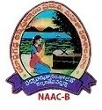

D E P A R T M E N T OF M I C R O B I O L O G Y
A C T I V I T I E S

( 2020-2021 )

Department of Microbiology Activities – 2020-2021

S.NO | NAME OF THE ACTIVITY | DATE
1. | World Toilet day | 19-11-2020
2. | Admissions campaign | 21-11-2020
3 | Student seminars | 02.02.2021
4 | Students quiz using kahoot | 16.03.2021
5 | Digital classroom- Student seminars | 17.03.2021

1.World Toilet Day: World toilet day was conducted on 19-11-2020. It was celebrated with the theme for the year 2020, 'Sustainable sanitation and climate change' which prioritizes the use of toilets for the health of humans.

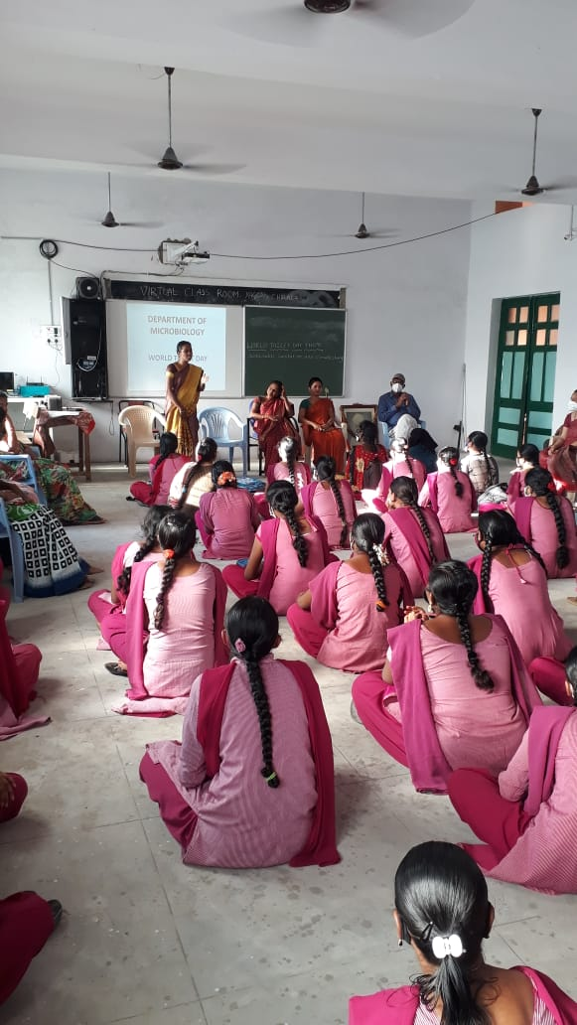

2. Admissions campaign: Participated in the Admissions campaign and also take part in the Help Desk activities, to encourage the students, in order to strengthen the student admissions.

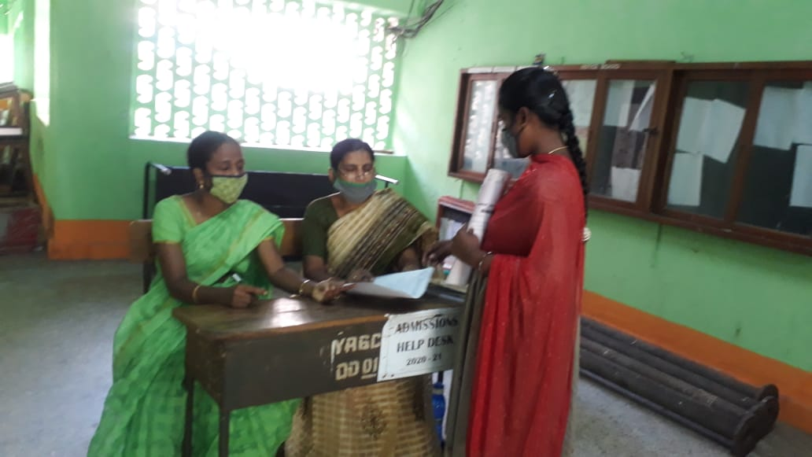

3.Student seminars:

Students’ seminars were organized on 02.02.2021 as part of their curriculum as well as to increase their abilities.

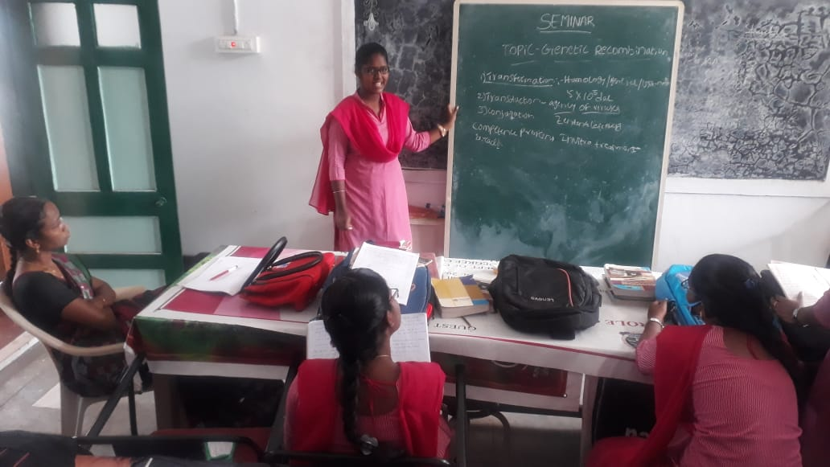
4. Quiz: Quiz was conducted on 16-03-2021 using Kahoot .Students was actively participated in the quiz programme.

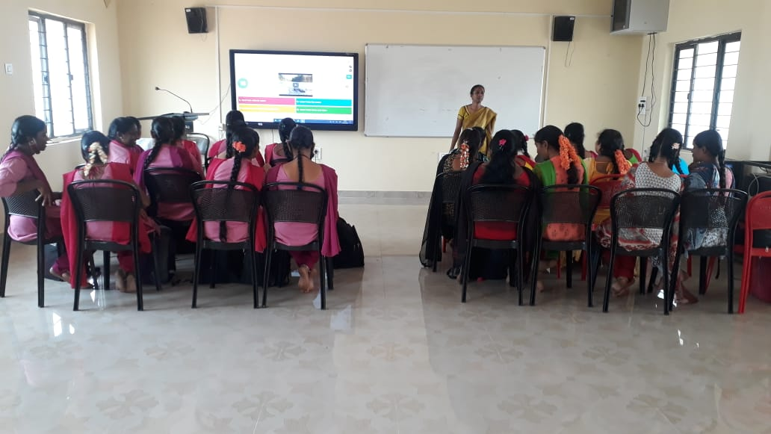
5. Digital classrooms & Student seminars: Student seminars were conducted on 17.03.2021 using digital class room.

